INFORMAtION AND COMMUNICATION TECHNOLOGIES (ICT)

A Comparative Analysis of Google Services, Microsoft Tools, Git, and GitHub

January 2, 2024

USTHB UNIVERSITY

2023/2024

# Introduction :

In today's digital age, Information and Communication Technologies (ICT) play a vital role in various aspects of our lives. This report aims to provide an overview and comparative analysis of popular ICT tools and platforms, focusing on Google services, Microsoft tools, Git, and GitHub. By examining their features, benefits, and use cases, we can gain a deeper understanding of how these technologies contribute to our digital experiences and collaborative endeavors.

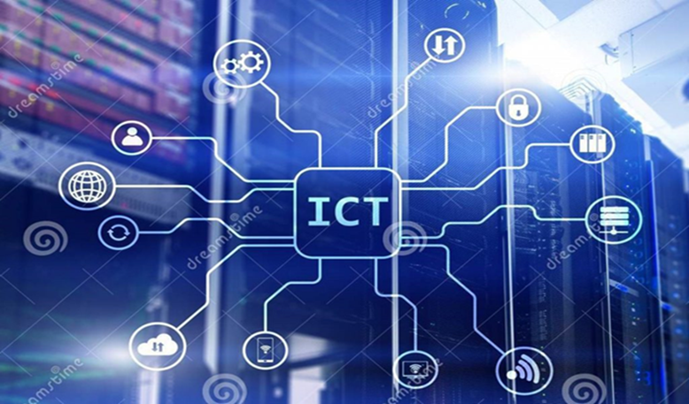

## 1.1. Connectivity :

ICT enables seamless connectivity, allowing individuals and organizations to communicate and collaborate across vast distances. With the advent of high-speed internet, mobile networks, and Wi-Fi, people can stay connected anytime, anywhere.

## 1.2. Communication Tools:

ICT provides a wide range of communication tools that enhance productivity and streamline interactions. Email, instant messaging, video conferencing, and collaboration platforms like Microsoft Teams and Slack have transformed how we communicate and collaborate in real-time.

## 1.3. Data Management:

ICT plays a crucial role in data management. Cloud computing allows for efficient storage, backup, and retrieval of data, eliminating the need for physical storage devices. Big data analytics and machine learning leverage ICT to extract valuable insights from vast amounts of data.



**1.4.E-commerce and online transactions:**

ICT has revolutionized the way we conduct business. E-commerce platforms enable online shopping, making it convenient for consumers and businesses alike. Online banking, digital payments, and secure transactions have become the norm, thanks to ICT advancements.

**1.5.Education and E-learning:**

ICT has transformed the education sector by introducing e-learning platforms and digital resources. Online courses, virtual classrooms, and educational apps provide flexible learning opportunities and reach a wider audience.

**1.6.Automation and Artificial Inteligence:**

ICT has paved the way for automation and artificial intelligence (AI) technologies. Robotic process automation streamlines repetitive tasks, while AI-powered systems enhance decision-making and provide personalized experiences.

[](https://www.iconfinder.com/icons/3695678/artificial%20intelligence_global%20solutions_information%20technology_internet%20things_iot_icon)

1. Google Services:

**2.1.Google Search:**

Google Search is a powerful search engine that enables users to find information from across the web quickly and efficiently.with its advanced algorithms and vast index,it has becime the go-to tool for information retrieval.

**2.2.Google Drive:**

Google Drive is a cloud storage and file synchronization service that allows users to store,access,and collaborate on files and documents. Its seamless integration with other Google services makes it a popular choice for individuals and teams.

**2.3.Google docs:**

Google Docs is a web-based word processing toot that enables real-time collaboration and document sharing .its intuitive interface and features like commenting and revision history make it a valuable tool for collaborative writing and editing.

1. Microsoft Tools

**3.1.Microsoft Office Suite:**

Microsoft Oficce Suite, includingword,Exel,and PowerPoint,has long been the industry standard for productivity tools. Its comprehensive features and familiarity make it widely used in various professional settings.

**3.2 Microsoft Teams :**

Microsoft Teams is a collaboration platform that combines chat,video meetings, file storage, and app integration.it facilitates seamless communication ans collaboration amoug team members, especially in remote work environments.

**3.3.tools:**

|  |  |
| --- | --- |
| Tool | Description |
| Microsoft word | Word processing softwar for creating and editing documents. |
| Microsoft Exel | Spreadsheet softwar for organizing and analyzing data. |
| Microsoft PowerPoint | Presentation software for creating visually engaging slideshows. |
| Microsoft Teams | Collaboration platform for chat, video meeting, and file sharing. |